HERO Initial Intake Application
We Care Forever (WCF) provides funds to organizations that work to improve the quality of life in disadvantaged communities. But we do much more.
To “improve the quality of life” means many things to many people. Our understanding is that effectively achieving this goal requires closely coordinated team actions. Each player on a team may be a star, but the team is stronger and capable of more than any one player. We see this in sports, in business, in government, and in families. It is critical to our hopes of success in areas where so many have not succeeded.
Joining the WCF family means actively performing as a member of an all-star team. We have commitments to our communities, to each other, to the future. We must talk to each other, help each other, and be open to being helped by other family members. Without this, the family falls apart, and improving the quality of life becomes a more difficult journey. So it is critical that you stay in touch and be responsive throughout the application process and once becoming one of our Heroes.
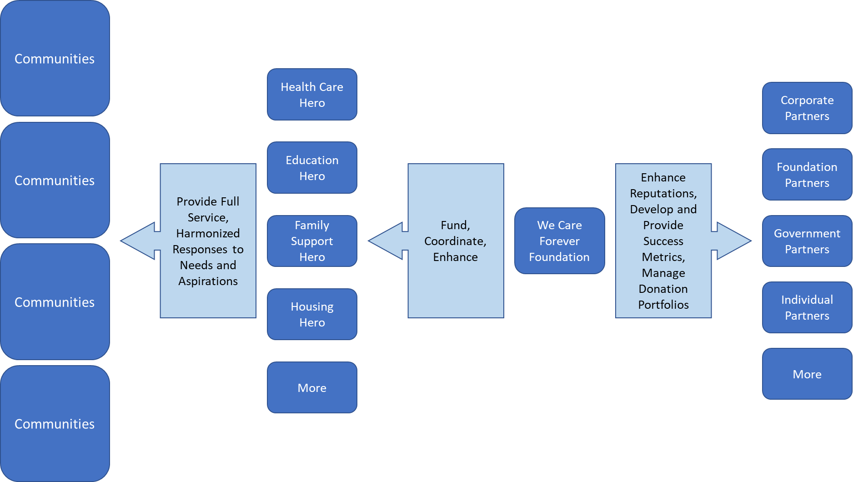
A rough diagram may help to explain how we approach this.

Filling out the attached application means being committed to working with WCF, other Heroes, and Partners. This may take the form of reports (plans, budgets, and accomplishments), responding to the needs of individuals and/or organizations presented by other Heroes, and actively engaging in discussions about improving the quality of life in minority communities.
Welcome!

Organization Name: ______________________________________
Web Site: ______________________________________________
Referred By: ____________________________________________
Contact Person and Title: _____________________
Email: _______________________________________
Telephone: _______________________________________

What has your organization’s yearly budget been for the last two years? (If funding and spending has been informal, use your best guess.)

Current Year | Last Year | 2 Years Ago
$ | $ | $

How much are you requesting? $__________
Is your request for a one-time grant for a specific project
or an on-going (semiannual or annual) contribution?

- Who benefits from the work your organization does? Why is this important? (Note that a full answer to this can be provided by listing links and/or by emailing attachments to applications@wecareforever.org using the subject line “Full Response Benefits – (your organization’s work)”.)

- Briefly explain what your organization does and how long it has been doing it. (Note that a full answer to this can be provided by listing links and/or by emailing attachments to applications@wecareforever.org using the subject line “Full Response What We Do – (your organization’s name)”.)

- What does “success” mean for your organization, and how did you measure “success?” Provide examples from your history. (Note that a full answer to this can be provided by listing links and/or by emailing attachments to applications@wecareforever.org using the subject line “Full Response Success – (your organization’s name)”.)

- How will your organization change this year? In three years? (Note that a full answer to this can be provided by listing links and/or by emailing attachments to applications@wecareforever.org using the subject line “Full Response Future – (your organization’s name)”.)

- What is your plan for making and managing this change? This year? Over three years? (Note that a full answer to this can be provided by listing links and/or by emailing attachments to applications@wecareforever.org using the subject line “Full Response Plan – (your organization’s name)”.)

- Briefly, tell us how joining the WCF family will increase your prospects for success (see Question #3). (Note that a full answer to this can be provided by listing links and/or by emailing attachments to applications@wecareforever.org using the subject line “Full Response Family – (your organization’s name)”.)

Finally, how will the funds made available by WCF impact your plans (see Question #5).?
Briefly explain how you intend to use the funds. (Note that a full answer to this can be provided by listing links and/or by emailing attachments to applications@wecareforever.org using the subject line “Full Response Funds – (your organization’s name)”.)

Please Email this and all supporting information to applications@wecareforever.org.

Thank you for your application.
We are looking forward to speaking soon.

The We Care Forever Foundation

